GRE TEST TAKING TECHNIQUES: VERBAL

The Verbal Reasoning measure contains three types of questions:

* Reading Comprehension
* Text Completion
* Sentence Equivalence

**Reading Comprehension (10 Questions)**

* Typically, about half of the questions on the test will be based on passages, and the number of questions based on a given passage can range from one to six.
* Rely on only the passage, not what you have known from other sources.
* After answering a question, go back to the passage, don’t rely on your memory.
* For main idea, check the opening and ending sentences of each paragraphs.
* Finish all related question for a specific comprehension. Never leave a second thought for a comprehension.

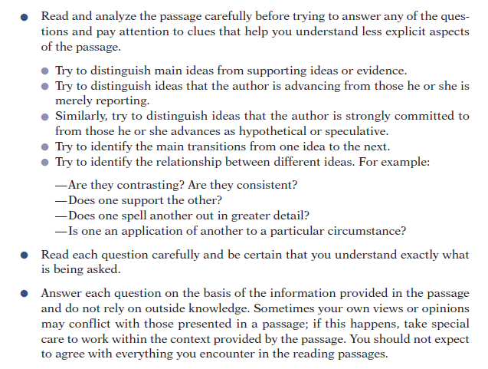

**One Answer Choice:**

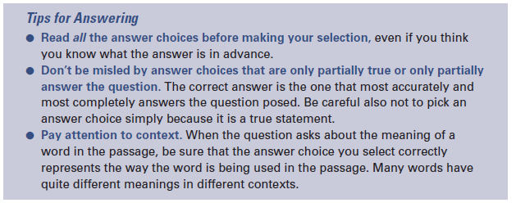

* **Read through the passage to get an overall sense of it.**
* **Identify words or phrases that seem particularly significant,** either because they emphasize the structure of the passage (words like although or moreover ) or because they are central to understanding what the passage is about.
* **Pay attention to context.** When the question asks about the meaning of a word in the passage, be sure that the answer choice you select correctly represents the way the word is being used in the passage. Many words have quite different meanings in different contexts.
* **Think up your own words for the blanks.** Try to fill in the blanks with words or phrases that seem to you to fit and then see if similar words are offered among the answer choices.
* **Read all the answer choices before making your selection,** even if you think you know what the answer is in advance.
* **Don’t be misled by answer choices that are only partially true or only partially answer the question.** The correct answer is the one that most accurately and most completely answers the question posed. Be careful also not to pick an answer choice simply because it is a true statement.
* **Double-check your answers.** When you have made your selection for each blank, check to make sure that the passage is logically, grammatically, and stylistically coherent.

**One or More Answer Choices:**

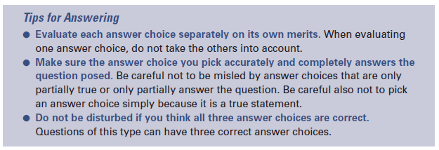

* **Evaluate each answer choice separately on its own merits.** When evaluating one answer choice, do not take the others into account.
* **Do not assume that the first blank is the one that should be filled first.** Perhaps one of the other blanks is easier to fill first. Select your choice for that blank, and then see whether you can complete another blank. If none of the choices for the other blank seem to make sense, go back and reconsider your first selection.
* **Make sure the answer choice you pick accurately and completely answers the question posed.** Be careful not to be misled by answer choices that are only partially true or only partially answer the question. Be careful also not to pick an answer choice simply because it is a true statement.
* **Do not be disturbed if you think all three answer choices are correct.** Questions of this type can have three correct answer choices.

**Select-in-Passage:**

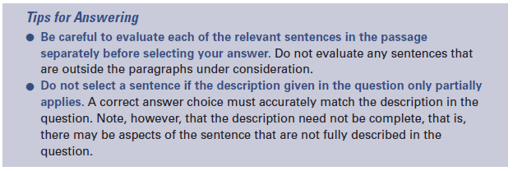

**Text Completion (6 Questions)**

Text Completion questions test one’s ability by omitting crucial words from short passages and asking the test taker to use the remaining information in the passage as a basis for selecting words or short phrases to fill the blanks and create a coherent, meaningful whole.

* Passage composed of one to five sentences
* One to three blanks
* Three answer choices per blank (five answer choices in the case of a single blank)
* The answer choices for different blanks function independently; that is, selecting one answer choice for one blank does not affect what answer choices you can select for another blank
* Single correct answer, consisting of one choice for each blank; no credit for partially correct answers

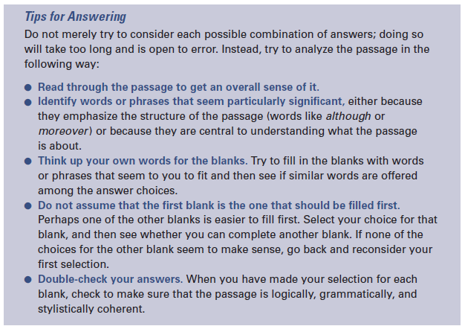

**Sentence Equivalence (4 Questions)**

Sentence Equivalence questions test the ability to reach a conclusion about how a passage should be completed on the basis of partial information, but to a greater extent they focus on the meaning of the completed whole. Sentence Equivalence questions consist of a single sentence with just one blank, and

they ask you to find two choices that both lead to a complete, coherent sentence and that produce sentences that mean the same thing.

* Consists of a single sentence, one blank, six answer choices
* Requires you to select two of the answer choices; no credit for partially correct answers.
* These questions are marked with square boxes beside the answer choices, not circles or ovals.

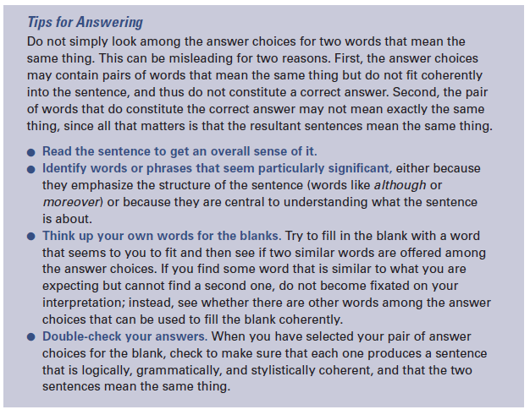

**Steps to Follow:**

1. Understand the meaning of the sentences
2. Explore the triggers/signal words
3. Try to do directly.
4. If not possible/time consuming then use POE.

Remember:

* Cause Effect signal words: Accordingly, as a result, consequently, for this reason, hence, in conclusion, in short, in summary, so, therefore, thus, given, if…then, in order to, so…that, when…then, because, …………..
* Same direction triggers: Semicolon (;), colon (:), and, not only…but also, besides, furthermore, in addition, in fact, just as…as, moreover, so as to, additionally, as well, indeed, likewise, too, also, ………….
* Explicit Contrast signal words/changing direction triggers: Albeit, Although, though, belied, but, despite, even though, except, however, for all, in contrast, instead, instead of, nevertheless, nonetheless, not, on the contrary, on the other hand, rather than, still, unlike, yet, in spite of, whereas, while, notwithstanding, by no means, whether…or, nonetheless, ………….
* Implicit Contrast signal words/changing direction triggers: Anomaly, illogic, incongruity, irony, paradox, surprise, unexpect, ………….
* Never rush through the first questions of a section.
* **Answer correctly-Remember that it is not the number of question that you answer that gives you your score; it is the number of questions you answer correctly.** Getting questions right is far more important than getting to every question. Remember that **accuracy is everything. Ignore the clock. Slow down and work for accuracy only. The minute you try to go faster, however, your accuracy will go down. There is only one exception to this, and that is the last two minutes of a section.**
* Try to answer all questions at first trial (it would be that you become unable to come back). If you are dubious about some questions use your guess and answer as far and mark them so that you can come back to them later. GRE offers the opportunity to mark a question and return to it.
* Never miss the last five minute warning. Use the Review button to quickly see which questions you haven't answered and then navigate accordingly. If there are so many questions unattended, rush…rush…and rush. Eliminate as many answer choices as you can and then guess.
* **Answer all.** A skipped question and a wrong answer count the same.